**Digital Marketing Training**

Recent studies show that Digital Marketing is the fastest growing sector in the tech industry. This course is geared to make you a digital marketing pro

In this tutorial, you will learn-

* Introduction to Digital Marketing
* Search Engine Optimization - SEO Tutorial
* Social Media Marketing: Tips and Secret
* Online Paid Advertising: Ultimate Guide
* Email and Mobile App Marketing

**Introduction to Digital Marketing**

Throughout centuries, marketing always remained customer centric, the way of delivering services and product has changed but the strategies remained same. Technologies did bring revolution in all fields and marketing is no exception, from print media to digital media. The rapid growth of digital marketing is the direct consequence of penetration of internet and social media sites.

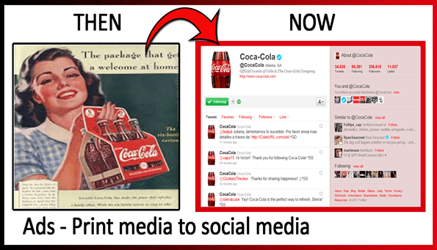

Unlike traditional marketing method you don't have to go door to door to convince people how good your product is, instead the 'likes' in Facebook and 'followers' in twitter does this job.

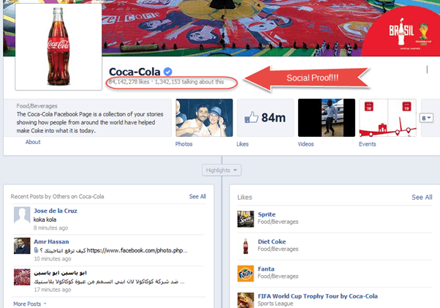

Digital Marketing revolves around four things

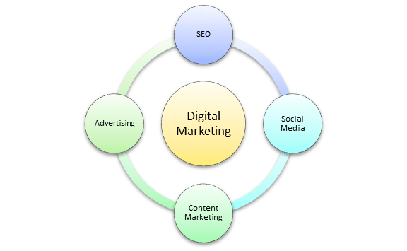

* **Social Media:** Interact with your customer base using social sites like Facebook and twitter. Use it as a support channel, Launchpad for new products , announce discount and exclusive coupons to drive sales
* **SEO:** SEO or Search engine optimization is a technique that allows a site to get more traffic from search engines like Google, Microsoft, Yahoo etc. It is divided in two categories, off page SEO and on page SEO
* **Content Marketing:** The goal of Content marketing is to retain and attract customers by consistently creating valuable and relevant content with the intention to engage targeted audience in order to drive profitable customer action. Content marketing is valuable for companies as information people find online impacts their purchase decision.
* **Advertising:** Online Advertising has multitude of benefits over traditional advertising and the chief difference is targeting.Most of the online marketing platforms accept banner/text/rich media ad formats which are billed in three ways CPM (Cost for Thousand) , CPL (Cost per lead) and CPC (Cost per Click). In CPM, the advertiser pays for each 1000 ad views that the ad gets, while CPC is the amount of money that is paid by advertiser to search engines for a single click on its advertisement that brings one visitor to its website. For every click the advertiser pays to search engines and online publishers. Another form of advertising is Cost Per Lead, in which the advertiser pays for an explicit sign up from an interested consumer who is interested in the advertiser's offer

**Search Engine Optimization - SEO**

**What is SEO?**

SEO is the process of improving the structure, content and organization of your site to the Search engines can index them correctly. It also involves doing promotional activities to boost your search engine rank

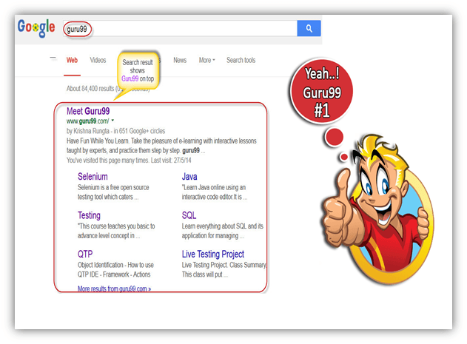

Before we look into this any further, let's first understand –

**How Search Engine Works?**

Almost every Search engine does the following ***Spiders or Web Crawling, Indexing & Displaying***.

* **Spiders & Crawlers:** Spiders crawl over the web in search of content (Hence the name Spider). Once they finish scanning and identifying the relevant content, they copy the searched content and store it in a search engines database. While they are scanning one web page, they make note of links to other web pages from this page and later scan the linked web pages as well & this process keeps going on for all webpages. ( For example : Page A links to Page B which in turn links to Page C. Here, Page A,B,C will be stored as well as any page which is linked from Page C ) .

Web Crawler will collect the following (not limited to) information from a web page –

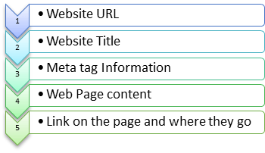

* **Indexing:** Now that website information is stored in Search Engines Database, how will it know which page to put on top of search results and which on last? Enter Indexing. Ranking is done based on **keywords**.

As the engines crawl and index the contents of pages around the web, they keep track of those pages in keyword based indices. The search engines have millions and millions of smaller databases, each centred on particular keyword term or phrase.

Next question, how does the search engine know which keyword to rank a page for? To determine so the search engine looks into the content of the page, Page Title , Page URL and other factors

Next question, suppose there 20000 Webpages each catering to the same keyword say football. How does the Search Engine determine which Page to display as # 1 , # 2 and so on… Enter Search Engine Ranking Factors which considers Domain Age , Domain Trust , Topicality , Number and relevance of external pointing links to the page , social signals and many more. This will be covered in detailed later in the tutorial

* **Displaying:** The last step in search engine activity is retrieving the best matched results for search queries, which is displaying the search result in browser.

**Role of Keywords in SEO**

Keyword is actually the key to SEO. Keyword is what a person or user enters into a search engine to find specific information.

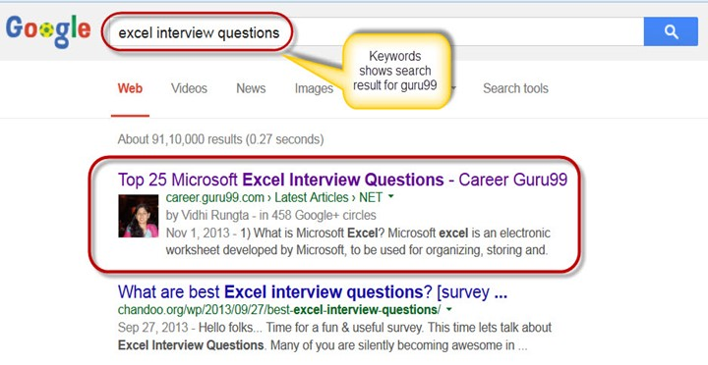

Keywords form part of a web page's metadata and help search engines to match page with an appropriate search query.

* **Keyword Density**

Often it is misunderstood that by including more keywords which describe your website can eventually help search engine to bring your website on top. Infact, more keywords sometimes get you penalized for "spamming "or keyword stuffing. So, using keyword wisely from SEO point of view becomes mandatory. So what is the ideal frequency of Keyword? It is believed that for best result, keyword density should be 3-7% for the major and 1-2 % for minor key words.

* **Keywords in Special places, Page titles & Headings**

It is imperative where your keyword exactly appears on your web page. It counts more if you have keywords in the "page title, the headings, the paragraphs" especially in URL. For instance, if your competitor's web page has same number of keyword as your webpage but if you have included the keywords in your URL then your webpage have more chances to stand out than your competitor.

Placing the keywords in the "Title of the page" or "Heading tags" is considered the best place to put your keywords. The reason behind is that the search engine looks first for the keywords in your "Title tag" and then in "Heading tag". The standard title tag keyword is around 70 characters max.

In order for a title tag to be most effective, it needs to be supported in other areas of each web page like the "headline". Your headline should be the largest headline on the page rich with primary keywords, you can also include secondary keywords in your headline. There is no limitation for headline length, but still preferred around 7- 8 words length. For keywords there are some set criteria for best result as shown in table below.

|  |  |
| --- | --- |
| Keywords | Criteria for best SEO result |
| Keywords in URL | First word is best position for keyword in URL |
| Keywords in Title tag | Keywords should be in beginning of title tags, 10- 60 characters , no special characters |
| Keywords in description meta tag | Show theme less than 200 characters |
| Keywords in Keyword meta-tag | Show theme less than 10 words |
| Keyword density in body text | 5- 20 % of the content |
| Keywords in Headlines | Use Hx font style tags appropriately |

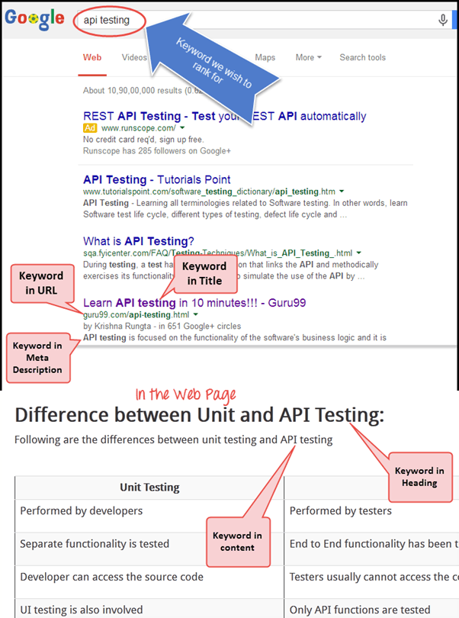

**Word Stemming**

Search engine like Google, uses word stemming for search query. Word stemming allows all forms of the word- singular, plural, verb form as well as similar words for a given search query. For example if someone search for "Mountain track" it will retain search result with all variation of that phrase like "Mountain tracking", "Mountain trackers" and so on.

**Ranking and Ranking factors**

**Meta-tags:** one of the earliest method to optimize the website high in result was to offer Meta data to the search engines. Meta data is nothing but the data about the data found on that page.

There are two important meta-tags or meta-data

* Meta description
* Meta Keyword

Both **Meta keyword** and **Meta description** can contribute to your search engine ranking. The meta description tag is intended to be a brief and concise summary of your page's content. The limitation for meta-description is about 170- 200 characters, writing a unique description for each page of your site. Meta description format would look something like this

<meta name="description"content= "Brief description of the contents of your page.">

**Example:**

Meta-description for website "guru99"

<meta name="description" content="Discover free online tutorials on Guru99.com to get ahead in your career. Start taking advantage of online learning today itself" />

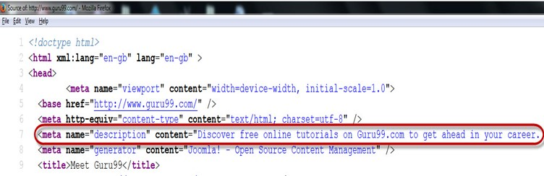

While meta keywords format would look something like this

**<meta name="keywords" content="keywords, keyword, keyword phrase,etc.">**

Example:

Meta-keywords for website "guru99"

<meta name="keywords" content = "free online education,SAP testing, etc.">

**Link Building**

**On Page & Off page Optimization**

SEO optimization is primarily classified into two sections on page optimization and off page optimization.

**Positive Off Page Optimization**

Off page SEO is the process of boosting your search engine rankings by getting external links pointing back to it. The more and better links you can get to your webpage, better it will rank in search result

A quality backlink is considered good from the search engines point, and has the maximum effect on your off page SEO. A quality backlink has properties like

1. Incoming links from high page rank web page
2. Use different anchor texts
3. Dofollow or Nofollow links
4. Getting backlink from similar niche blog or website
5. Avoid black hat SEO
6. Good Domain Authority
7. High Trust
8. High Relevance in the subject matter of the linking and destination domains
9. Site Age- Shows site stability

**What you should NOT do for Negative off page**

* Link Buying : If you get caught penalty is huge
* Cloaking: Try prevent cloaking (representing different page to search engine than your original web page)
* Domain Hi-jacking: It is when someone takes your domain away or misuses your domain without your knowledge by changing the registration of the domain name. Never do this, it's a criminal offence.
* Other Black Hat Techniques

**Positive On Page Optimization**

On page optimization directly deals with the content and structure of the website. On page optimization focuses on

1. Unique title tags and Headlines
2. Keyword frequency in the

* URL
* Body Texts
* Headings

1. Synonyms
2. Copywriting
3. Adding description to images
4. Good Internal Navigation

**What you should not do for Negative On Page**

* Avoid negative over optimization penalty (OOP) by not repeating keywords very very frequently
* Link to a bad neighbourhood : Do not link to link Farms or any other site with bad page rank
* Avoid Poison words: The word "link" is considered poison words or stop words in a title tag. There are many other poison words that you should avoid
* Avoid stealing text or images from other domains
* Avoid Excessive cross linking
* Avoid re-directing users to another page through refresh meta-tags, don't immediately send your visitor to another page unless he/she clicked on

For best SEO result for your site always regularly maintain it, as you won't rank as high in search engines, if your site is slow or has broken links.

**Google Panda**

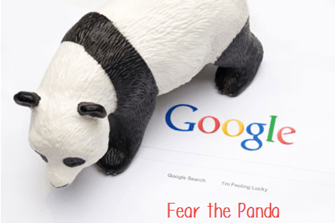

Google panda is a Google's search results ranking algorithm, it aims to lower the rank of "low quality sites" or "thin sites" and return higher quality sites near the top of the search result. In other words it does the verification of "content" of the websites.

**How to escape the Panda's Claw**

Try to avoid link building with those sites which is already ranked as low quality website

Watch out for sites that are peppered with Google adsense

Avoid sites with little or no moderation, especially those sites which accepts your comments or blog quickly for their websites

**Google Penguin**

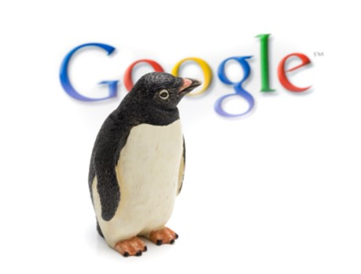

Another algorithm update from Google is "Google Penguin" which penalizes those sites that breach Google's webmaster guidelines set by the search engines. This programme is specifically designed to target those sites that practice black-hat SEO techniques like keyword stuffing, duplicate content and bulk link building to name a few. Penguin does not damage the site unless spammed for too much keyword.

**How to get away from Penguin's Pecking**

1. Remove all links from guest blogging network
2. Remove links from spam sites
3. Remove all exact match anchor links
4. Remove all optimized anchor links
5. Nofollow Guest Post links

**SEO Audit and Link Removal**

SEO Audit and link removal is very important for running your website successfully, as search engine modifies their algorithm from time to time. For success of your website, it is necessary to keep pace with their current guidelines and requirements of search engine. To ignore link audit may put your website at high risk.

For link audits and link removal many online tools are available like, Google webmaster tools, MOZ , Open Site Explorer , Majestic SEO etc. It will scrutinize 'backlinks' and provides some helpful metrics like

* Specific URLs that link to your site
* The pages on your site that each of these URLs link to
* Anchor text used by each incoming link
* Whether each incoming link is follow or no-follow

While removing low quality links, you have to be careful as some of them may be highly relevant to your website and come from websites on the upswing. In future they might become an important source of traffic.

**What are the characteristics of a *'bad links'***

* Links with the same anchor text coming from multiple sites
* Links from sites that are unrelated to your niche
* Links from low traffic and low PR ( Page Rank)
* Links from articles directories or sites that look like link farms
* Links from link exchanges
* Paid links
* Links from sites that are not in the Google Index
* Spammy links in blog comments

In case the site owner does not remove bad links from your website, then you can use Google's disavow tool. This disavow tool will remove bad links.

This disavow tools are applicable in condition like

* When you get a manual action
* Webmaster won't remove the bad links to your site or charge you to remove them
* When you see links pointing to your site you do not want to be associated with
* When you are worried about negative SEO
* You see links pointing to your site you do not want to be associated with
* You saw a link bomb attack and are afraid it might hurt your site
* You are afraid someone will submit a spam report for you
* You see your ranking dropped and you think it has to do with an algorithm Google ran, example: Penguin algorithm

**Social Media Marketing: Tips and Secret**

Social Network Marketing is about using social media sites as marketing tools for the optimization of revenue or increasing brand exposure. Social Media Marketing use strategy like SMO (Social Media Optimization), it can be done in two ways

1. Adding social media links to content such as sharing buttons and RSS feeds
2. Promoting sites through social media by updating tweets, blog post and statuses

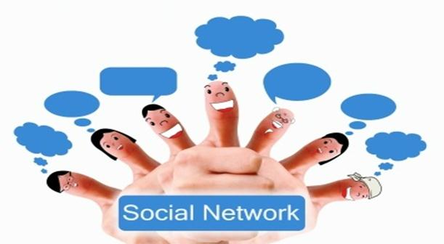

Social Media Marketing helps a company get direct feedback from customers, social websites like Twitter, Facebook, Instagram, Myspace, Linkedln and Youtube which have had significant contribution in social marketing in last couple of years. The success of social media in marketing is due to very "Personal" interactions between the user and service renderers.

**FaceBook Marketing**

Face book features are more detailed than other social networking sites. They allow a product to provide photos, videos, longer description option and testimonials as other followers can express their opinion on the product page for others to see. Facebook can link back to the products twitter page as well as send out event reminders. This can be done by connecting to various groups or business groups of your field on Facebook, admin page and direct message to admin for site promotion. You can also create your own personal page where you can upload videos or website information for example, here we have "Guru 99" Facebook page, which has reached many e-learners through Facebook.

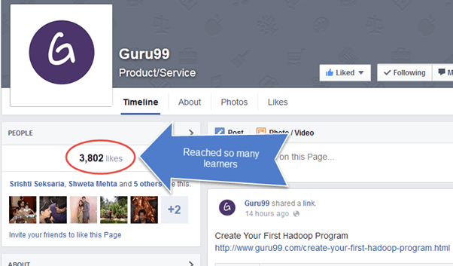

Next you can also make a group or join a group of your liking, for example if you are a computer geek and searching for a java computer group then you can join a Java group where you ask questions pertaining to java or share any information related to Java with your group.

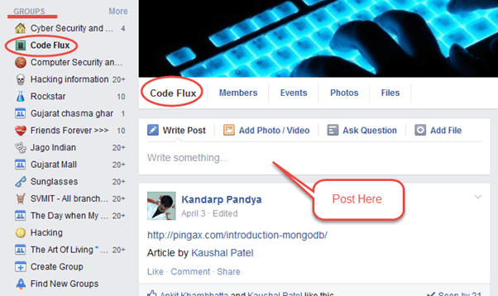

To facilitate social media marketing and to manage posting of messages on regular basis on social sites, automated scheduling tools are used. Hootsuite is one such tool, which gives users extended facility for automating and scheduling messages, monitoring conversation and track result across multiple networks. For example, here it is shown how different tutorials are set and scheduled for website Guru99.

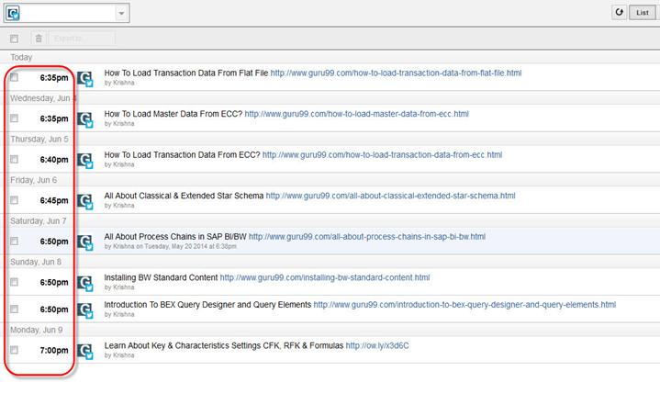

**Twitter Marketing**

It's a micro blogging service that allows sending and receiving message from customers. This can help business people to contact and communicate with peer group and to their customers. You can create your personal page in twitter as well, and can upload your site and share information related to site on twitter.

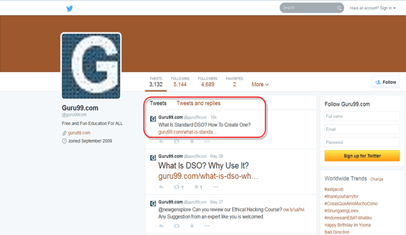

Twitter is a great tool to reach out new customers/clients without invading their privacy

**LinkedIn Marketing**

LinkedIn connects professionals from various backgrounds and provides an opportunity to expand business by connecting business professional. Through the use of widgets, members can promote their product or website directly to their clients. "Company Page" is one such feature in linkedin which acts like a business resume for your client to get a quick overview about your business.

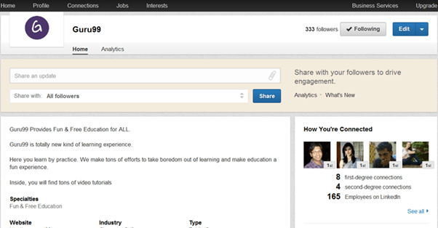

Your personalized webpage on linkedin can also be used as an open platform for discussion with peer group or e-learners. Apart from your personalized page there are option like joining groups, companies or any particular professional groups (Doctors, Real estate & Infrastructure, Job portals, business groups etc.)

Recent research has marked Linkedin on top for social referrals to corporate homepages.

* LinkedIn: 64% of social referrals to corporate homepage
* Facebook: 17% of social referrals to corporate homepage
* Twitter: 14% of social referrals to corporate homepage

**Google+ plus**

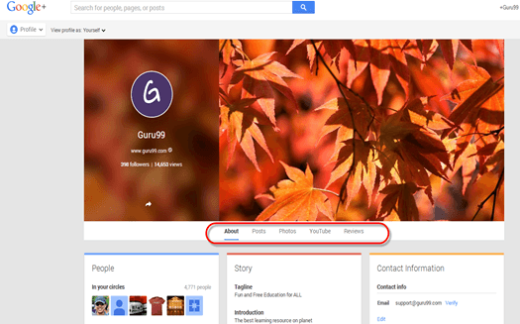

Google plus provides various features which can be used for marketing purposes like

* Circles : You can create groups or join circles of your likings
* Stream: Gives instant updates on selected contacts or groups
* Photos: Upload photos
* Sparks: It allows you to specify your area of interest every time you logged in
* Plus One: It is like a face book 'like button', where you can express your opinion about any particular product
* Video Chat and Huddles: All queries can be solved by video chat facility which can be used to facilitate live customer interactions and huddles allow for group chats.

Apart from these you can join communities of your interest, like here guru99 has created community for software testers where they can use these page for discussion for topics of their common interest.

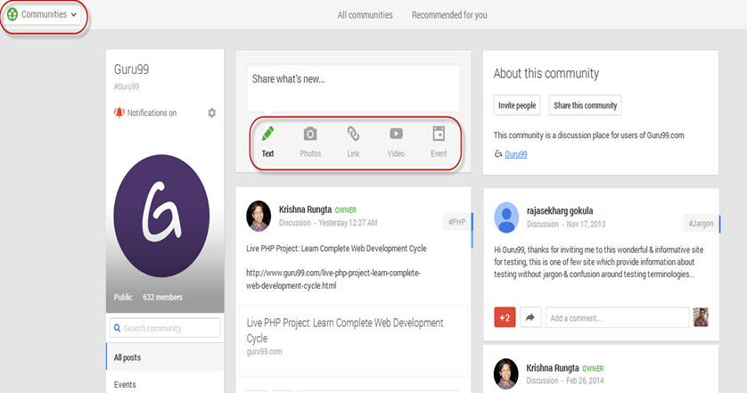

**Video Promotion**

Video's are one of the quickest ways to reach your customer. Visual effect has more impact on customer than print or digital text, it enables to explain the product more convincingly than any other medium. Marketing on "Youtube" turns, viewers into fans and, fans into customers. Also with video pages on your site has more chances to get good rating, as there are very less competition for video pages.

One way of doing this is to embed multiple videos onto one web page to create a series of related videos. Another option is to re-purpose your videos to produce related content. It includes presentation, screenshots as podcasts and images, transcription and PDF downloads.

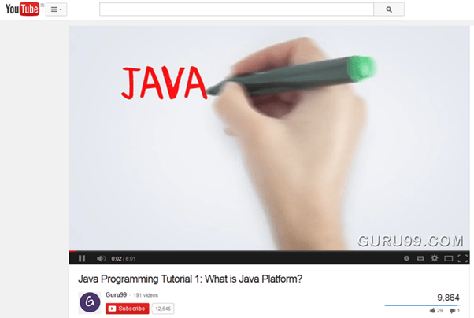

To get maximum viewer to your video link, attach the script of your Video. Youtube also provide captioning alternative for videos.

**Online Paid Advertising: Ultimate Guide**

Pay per click advertising or PPC means that you pay each time a customer or user click on your ads. You pay up to your bid amount and not more than that. One of the most popular pay per click program is run by Google is called AdWords.

Pay per click (PPC) marketing is collaborative, complex and iterative. Pay per click marketing revolves around keywords. The screen shot below demonstrates how google ad looks like.

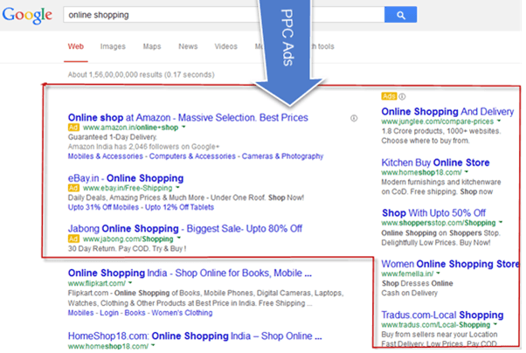

* Several aspects important for successful PPC campaign
* First Understand the purpose of PPC campaign
* Research on your target audience
* Keyword Research
* Perform A/B Testing
* Learn from your competitors Ad copy before you make your own
* Keyword grouping and Organization
* Keywords in Ad should include keywords of the landing page
* Ad groups creation and Management
* Managing your PPC campaign
* Once you have created your new campaigns, you have to make sure that they remain active and effective and for that you have to manage your PPC campaign properly
* Continuously analysing the performance of your account
* Add PPC Keywords and expand the reach of your PPC campaign
* To improve campaign relevancy, add non-converting terms as negative keywords
* Split up your ad groups into smaller and more relevant groups.
* Stop the underperforming keywords
* Modify the content and call to actions (CTAs) of your landing pages to align with individual search queries in order to boost conversion rates
* Don't send all your traffic to same page

|  |  |
| --- | --- |
| Example for Bad Ad | Example for Good Ad |
| Hob's black coffee | Hob's great organic black coffee |
| Selling coffee since 1947 | Refreshing and High quality |
| Come and see our selection | Special discount on imported black coffee |

**Facebook Ad**

Facebook provides their users unique facility for advertising their product or services. Facebook gives option like **Click to Website**, **Website Conversion**, **Page Post Engagement**, **Page Likes** and so on. Here we have selected option **Click to Website**, when you enter the URL of your website and click on continue it will direct you to the ad page.

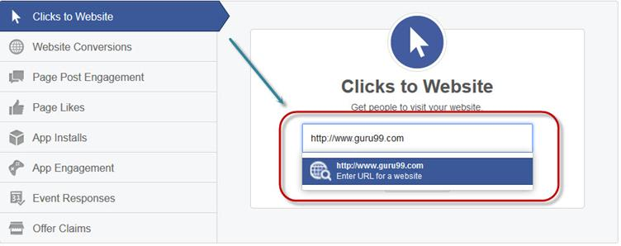

Once you enter your URL to the ad page, the next step will be to upload the image for your ad that you want to display when users look at your ad. Here in the screen shot we had uploaded an image showing **"Free Live Selenium Project"**.

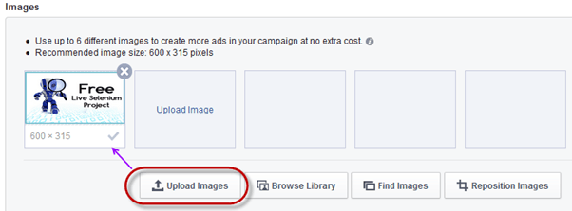

On the same page you can set the headline for your ads like here we have put the headline **"Live Selenium Testing"** the other feature is **call to action** or **click button** if you want to display button on your ad as **shop now**, **book now** and so on. You can select this button as per your requirement, here we have selected **No Button Option** as we don't require button display on our ad.

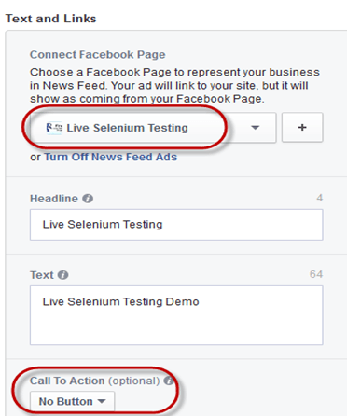

Once you have uploaded ad image the next step is to identify and target your audience for ad. On ad page you can handle your account as shown in below screen shot and you can target specific audience by narrowing down them according to their **location**, **age**, **gender**, **language** and so on also you can bid from the same page.

Here, we had chosen country like India, U.S and U.K and we targeted the audience between the age of 19- 24 for our ad and set the rest of category accordingly.

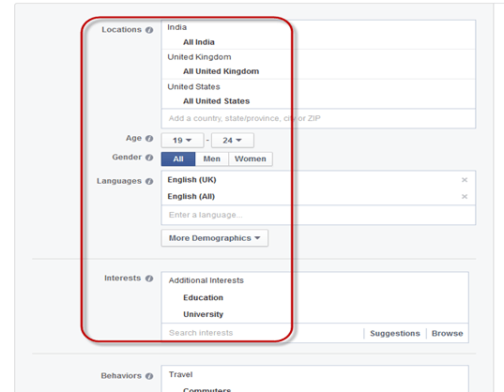

The next step is to set the limit for your ad like how much money you want to spend for your ad and you can set the amount limit accordingly. For instance, we have set the limit Rs 100 per day, then your ad will display on Facebook till your amount becomes nil for the day.

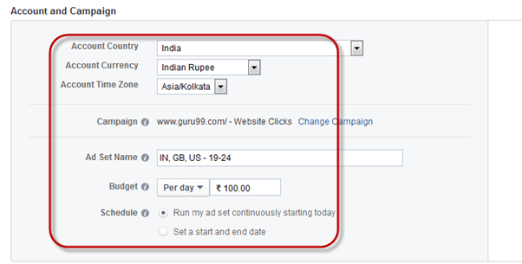

Bidding and Pricing is the next step where you can select your option of how you want do payment to the advertiser, whether you want to pay for ad for the number of clicks (**Bid for clicks**) or want to pay on just impression of your ad (**Bid for impression**). After selecting either of this option you can click on **Place Order** and you will moved to the final step of Facebook ad.

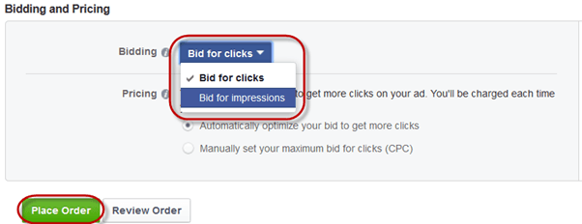

Once everything is set up, you will be proceeded to the most important part and final step of the process, yes you guessed right, money in the bank, as soon as you are done with the payment thing your ad will be reviewed and approved by Facebook group and soon your ad will start displaying on your account.

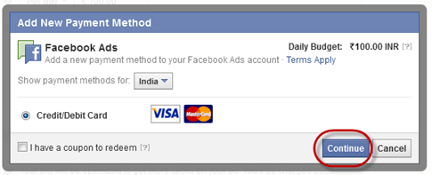

For the desktop users the ad will display something like this as show in the screen shot below

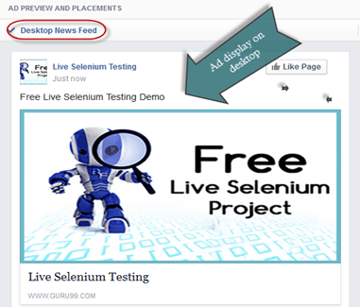

While for mobile users the ad will display like this, as shown below

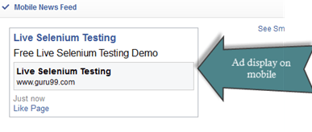

**Twitter Ad**

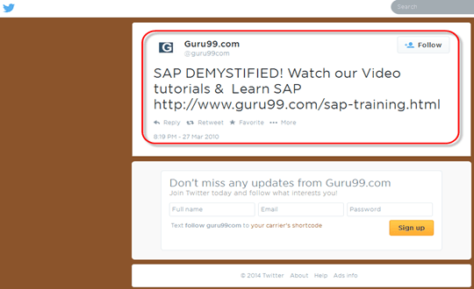

Twitter ads are directly implemented right into the timeline of Twitter so they not only fit in, but do not distract the viewer's experience.

**Twitter's Ad Types**

Twitter has exceptionally shown its potential in online marketing through promoting Ads and product. Some of these ad types are emphasized over-here.

* **Twitter new Ads arrival with Download options:** This new type of ad allows users to download apps through twitter and is an attempt to bring in the lucrative gaming advertisements to twitter. In addition to that,

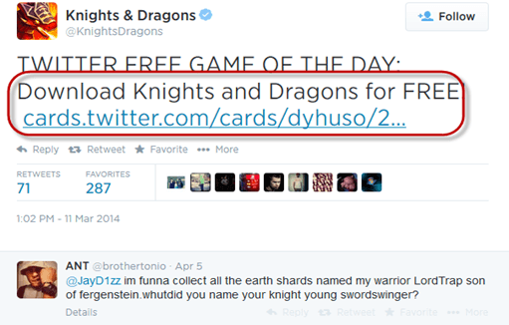

* **Ads with click to call button:** Like Facebook, twitter is going to introduce click to button option on twitter account, for direct access to the advertisers. It will allow interested consumer to reach their product of interest in single tab

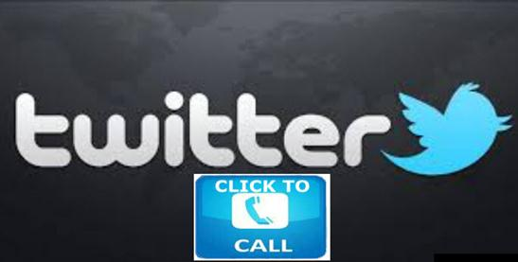

* **Promoted hashtags , promoted account, promoted tweet:**

**Promoted hashtags:** Promoted hashtags can get people know about your product or topic. Clicking on hashtags can show all tweets that include that hashtags

**Promoted Account:** It can help to build followers and generate awareness. Promoted account priced on CPF (cost-per-follower) basis with advertisers only paying for new followers gained

**Promoted Tweet:** Promoted tweet to any target can bring awareness, engagement and reach the followers. Promoted tweets use cost-per-engagement pricing. A twitter engagement is considered if users clicks on promoted tweet (a retweet, reply, favourite or follow). The advertiser only pays for the first engagement.

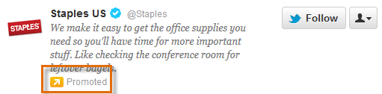

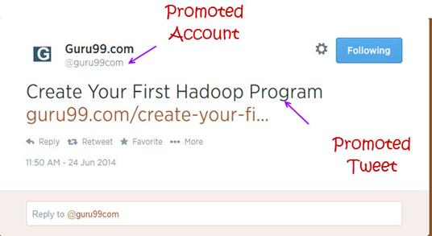

**Twitter Cards**

With Twitter cards, you can attach rich photos, videos and media experience to tweets that drive traffic to your website.

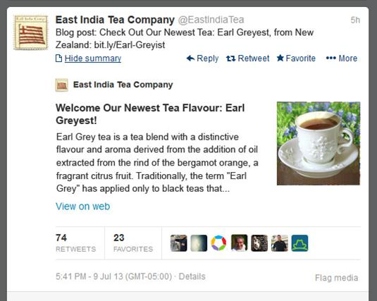

**Email and Mobile App Marketing**

With the use of internet, e-mail marketing has become more prevalent and common method to reach maximum users with minimum costs. It is a form of direct marketing that uses electronic mail as a means of communication. E-mail marketing is an efficient way to stay connected with the clients and at the same time promoting your business and products. With e-mail marketing you can also track how much percentage of people have shown interest in your product or service. Professional e-mail marketing is considered as a better approach for organized marketing strategy. Here are some benefits for e-mail marketing.

* **Permission based list building:** It is a creation of an email list by providing a sign up box for for prospective e-mail contacts and confirming their approval with a follow up email
* **Campaign creation:** The capability to organize and structure large volumes of e-mail messages by branding, theme and schedule
* **Online reporting:** Track the sending of individual email campaigns and at what rates they were opened and which e-mails are not open or bounced
* **Rich content Integration:** Addition of graphics, video, audio and test using templates,drag and drop editor
* **List Management:** The ability to organize, segment, edit, grow and manage a database of customer or client e-mail contact information

**How to implement successful e-mail marketing campaign**

There are some simple tips for effective e-mail marketing

* To grab the attention of your readers, make sure that your subject line or title should stand out. Need to keep message short and to the point
* Your logo needs to be highlighted clearly at the top of the e-mail
* Stress first two or three lines of your e-mail to make an impact
* Provide link for the landing page on your website
* Collect e-mail addresses at offline events like trade shows and import them into your database and send them a welcome email
* Promote offers and e-mail sign up through Google plus company page

**Automate scheduling for e-mail**

E-mail schedule can be of great help when one has to mail same document or message to different people on regular basis in bulk. Automation of e-mails are not restricted to sending and receiving mail but also account for other activities like deleting unwanted emails automatically, save e-mail attachments into local folders, e-mail integration with text files or csv and so on. Aweber is one such platform where you can manage and automate your mail and schedule your mail according. As shown in screenshot below, we have schedule each message or tutorial on JavaScript and send to subscribers by scheduling it one after the other.

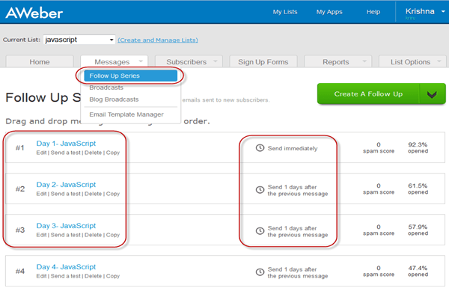

There are many e-mail service providers which does not have automation scheduling in-built, for them extensions are available and can add on this extension to their mailing system. For example, "Boomerang" which can be used in Google chrome or Firefox for scheduling e-mails. Mail Chimp is another mail manager where you can set data, time , batch delivery and so on for your mail .

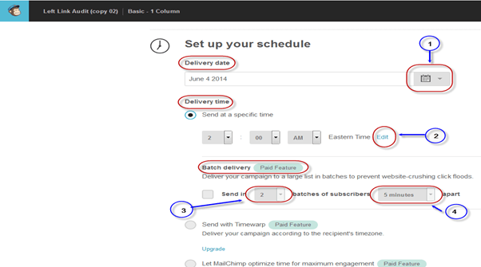

he important feature of mail chimp is that it keeps the track record for their subscribers and give information like who all have looked into your messages, which links they clicked and from where they have access the link ( Geo-location) and vice versa.

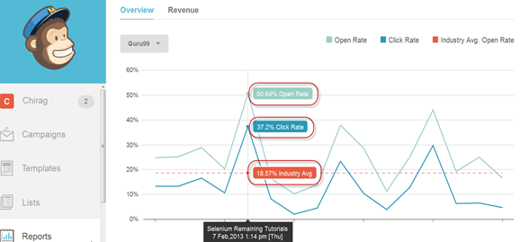

**Mobile App Marketing**

While building your mobile App there are certain things that needs to be work out

* **Growing your social media presence:** Building a steady social media following on Facebook, Twitter, Google+, Tumblr
* **Driving engagement across the app:** Focus your efforts on encouraging ongoing engagement and keep updating fresh content so to prevent users from losing interest in your app
* **Increasing app store ratings:** Try to improve rating of your app, this will drive a lot traffic to your app
* **A steady rise in app downloads:** There is always more revenue when there is more download of your App, so if you have a valuable product it automatically increase the download rate.

**Promo video for mobile APP**

* As a part of viral marketing campaign, a promo video is quite essential.
* Create a promo videos which is short and informative.
* Highlight all your app's key features and point out why your app is better than its competitors
* Also, include screen shot of your app as well
* Once the video is ready you have to be active in marketing or distributing that video over the web. Post it on forums, use social sites like Facebook and twitter to reach out maximum, upload it to youtube and so on.

In the end, if you create a GREAT mobile app, people will do the marketing for you!. Here, we will see a mobile app for company Guru99.

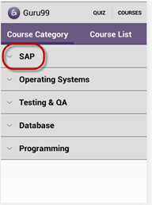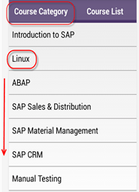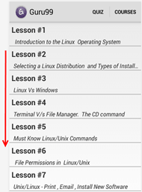

**Web Analytics**

Web analytics is the study, analyses and reporting of a web data for purposes of understanding and optimizing web usage. This technique is useful to measure how many people have visited a site, and how frequent they have visited the site or what route they have opted to reach your site. Web analytics is very useful from the point of administrator as they can figure it out which area of the site is popular and which area is not.

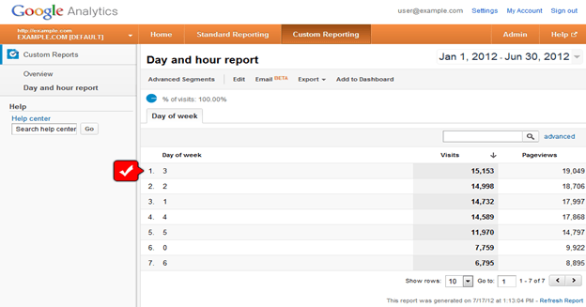

Web analytics software can be used to monitor whether your site page are working properly or not. There are various web analytics software available in market, some of them are Google Analytics, Adobe site catalyst, IBM coremetrics web analytics, IBM's Unica Netsight, yahoo marketing dashboard, Piwik, Moz and so on.

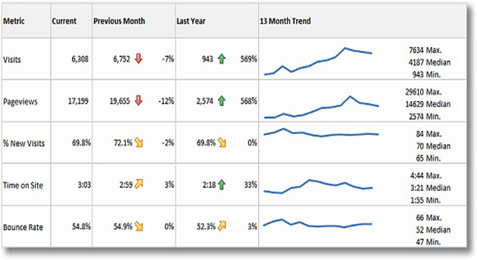

A good analytic tool should meet following criteria

* Can you re-analyze data if you decide to change something
* Can you re-analyze subsets of your logs for more focused views
* How many web pages does the solution track per month
* What is the total cost of ownership
* Does it integrate easily with other sources of data